# ITP 499, Fall 2021

# Homework 6 24 points

**Problem**

Go to <https://poloclub.github.io/cnn-explainer/> and explore various CNN layers.

Then answer the following questions.

Insert screenshots to support each answer.

1. Why are the red, green and blue channels in grayscale? (2)

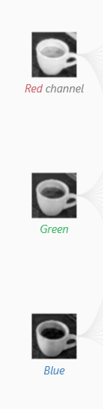

Because each channel is a 2D(not 3D) matrix and can be regarded as a grayscale image.

1. Why are convolutional layers, relu layers and pooling layers in shades of red through blue? (2)

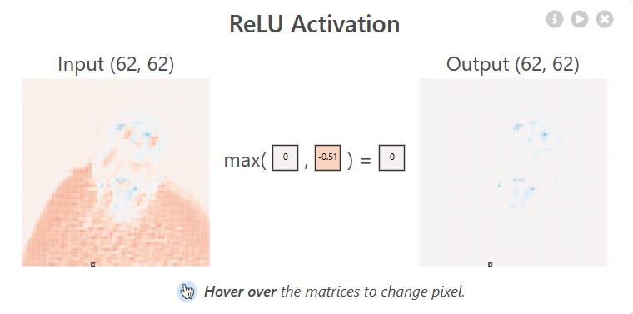

Because the output maps of conv layers contain elements less than 0, which is red. While the activation maps of relu layers only contain elements greater than or equal to 0, which is blue.

1. Considering that there are three colors channels in the input layer, how many filters are in conv_1_1 layer? (2)

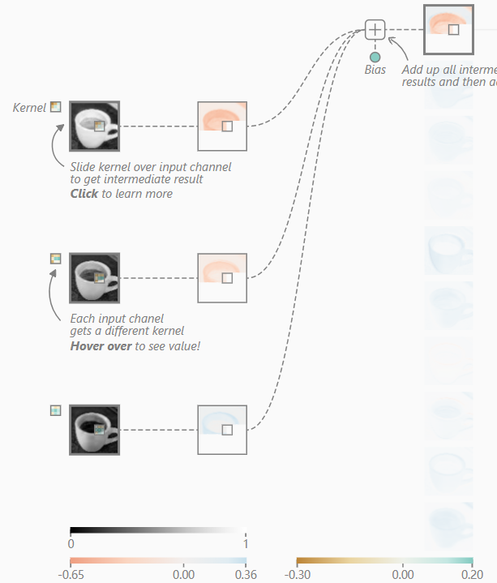

There are 3 unique filters for three channels in an output neuron in conv_1_1, and there are 10 neurons in conv_1_1, so there are 30 filters(kernels) in conv_1_1.

1. Calculate the total number of parameters needed for conv_1_1 layer. (2)

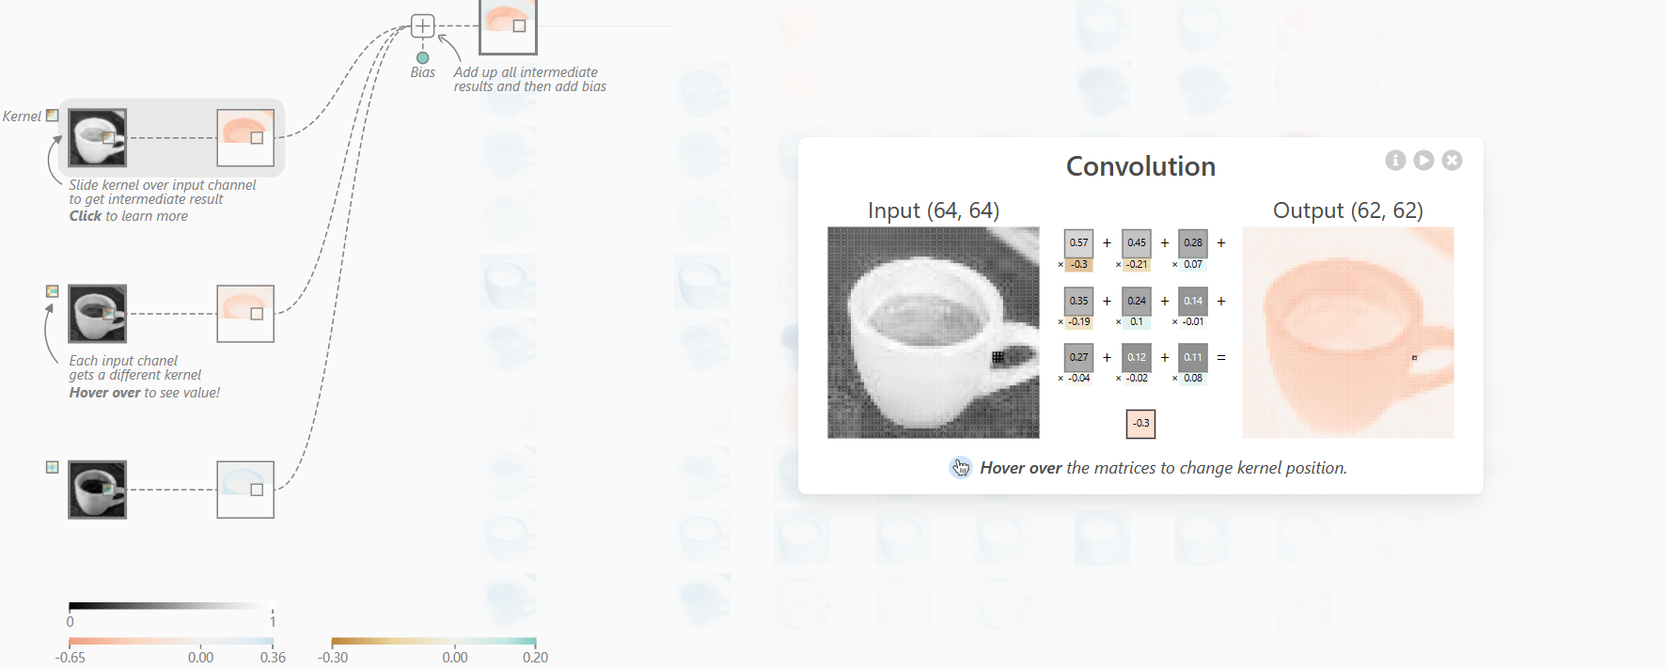

There are 3x3 parameters for each filter and 1 bias parameter for each neuron, so there are (3x3x30)+1x10=280 parameters for conv_1_1.

1. What is the size of the filter (kernel) for conv_1_2? (2)

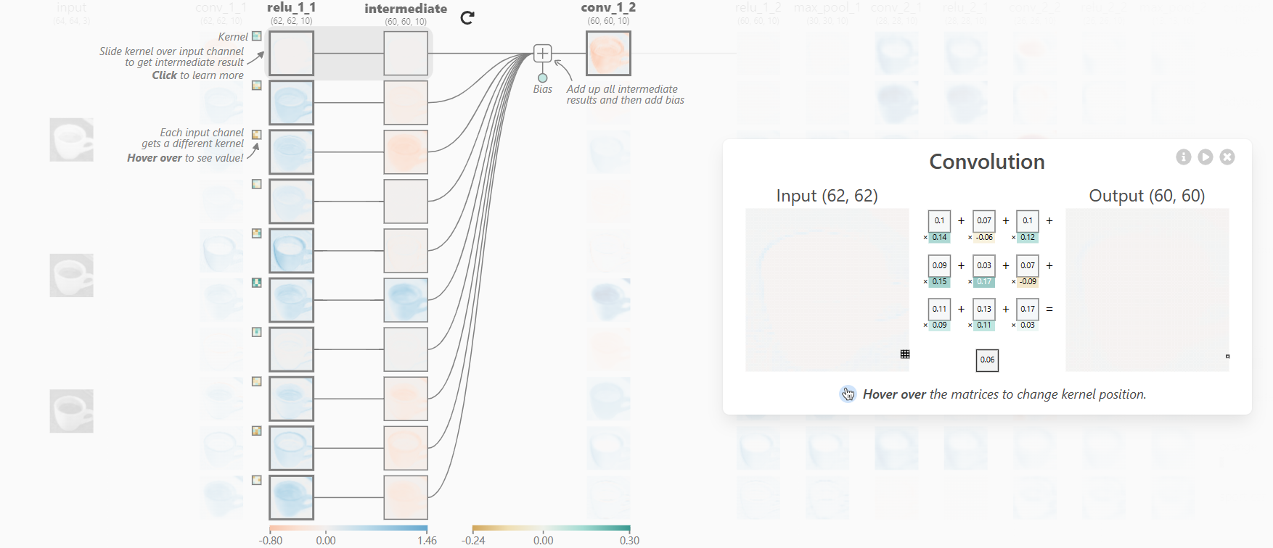

It is 3x3.

1. Show the weights of any single filter. (2)

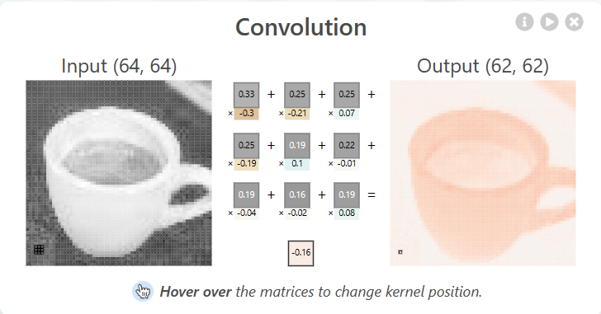

The filter weights for red channel of the topmost neuron from conv_1_1.

|  |  |  |
| --- | --- | --- |
| -0.3 | -0.21 | 0.07 |
| -0.19 | 0.1 | -0.01 |
| -0.04 | -0.02 | 0.08 |

1. What is ReLU? From the demo, show how ReLU outputs 0 for negative inputs. (4)

The ReLU is a activation function applied one-to-one mathematical operation:

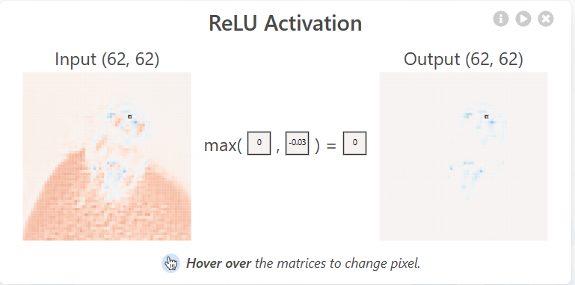

It is indeed a max function.

1. What is the size of the kernel in the max_pool_2 layer? (2)

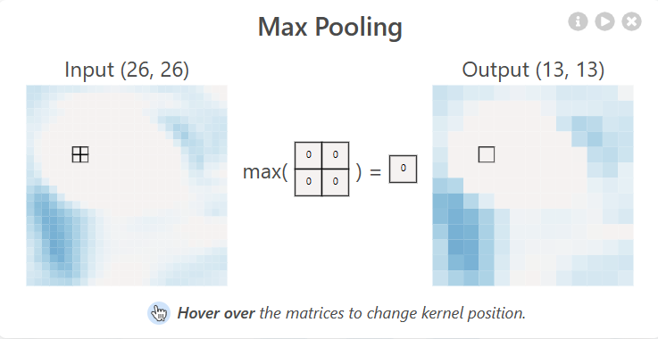

2x2.

1. Show that the max_pool_layer is indeed using a max function. (2)

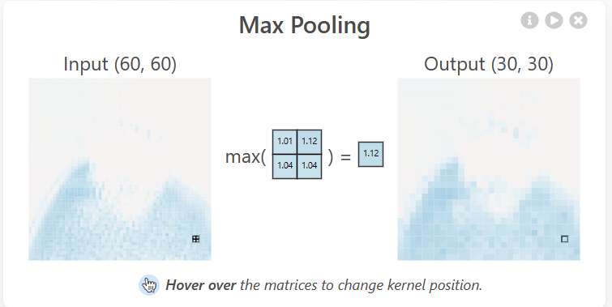

As we can see below, max(1.01, 1.12, 1.04, 1.04) = 1.12

1. In the softmax layer, show where the probability of *ladybug* class is computed. Display the formula (2)

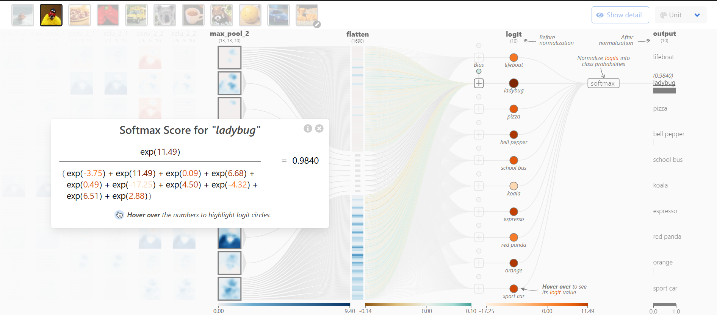

It is computed after the logit layer.

1. Add an image that is similar to one of the 10 classes in the output. Show its classification probability. (2)

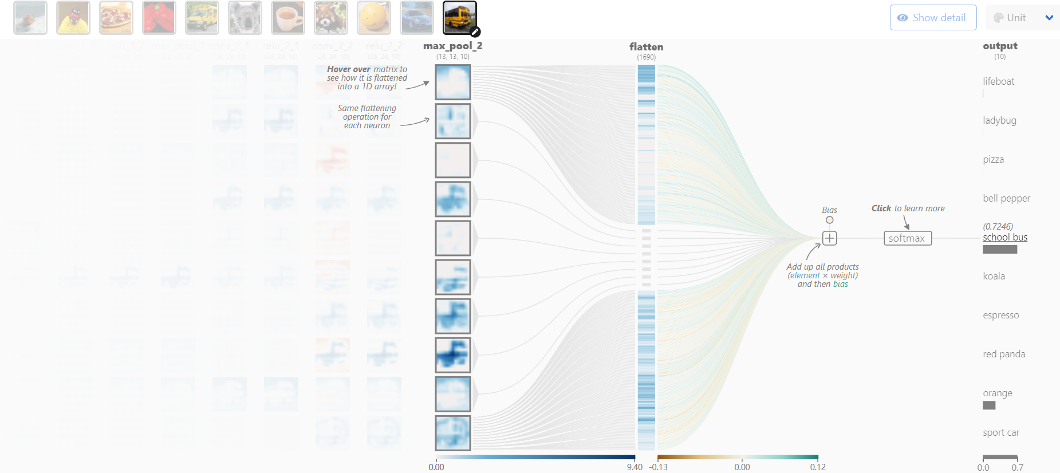

I add a school bus image, and its classification probability is 0.7264.

1. Add an image that is dissimilar to one of the 10 classes in the output. Show its classification probabilities. (2)

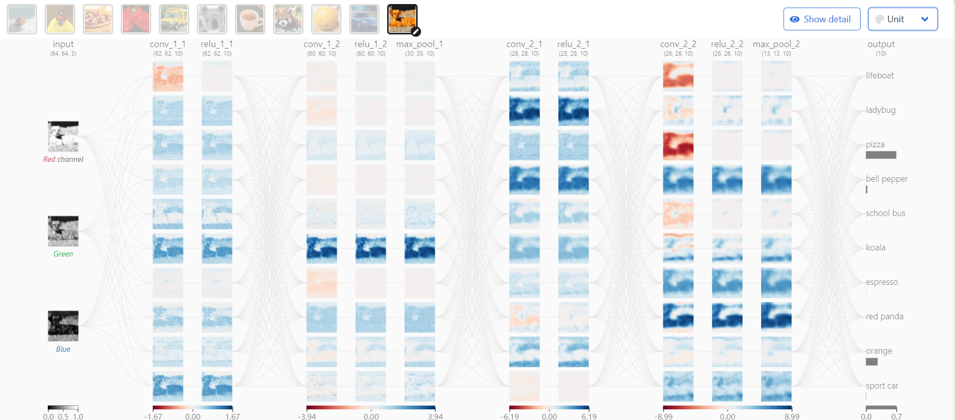

I add a dog image, and it’s classification probabilities are 0, 0.0003, 0.6905, 0.0328, 0.0017, 0, 0.0023, 0, 0.2658, 0.0066.